**OVER VIEW OF MY WORK IN THIS PROJECT**

**NAME: MONISHA S**

**NAME OF THE COMPANY: RENOVATIO DESIGN SOLUTION**

**ROLL: FULL STACK DEVELOPMENT**

**MODE: HYBRID**

**CERTIFICATE:**

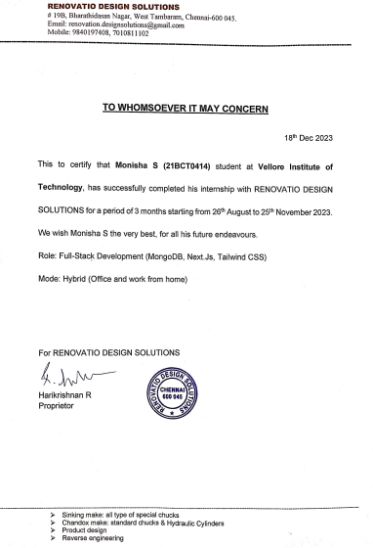

**ADMIN DASH BOARD OVERVIEW**

**ADMIN DASHBOARD INCLUDES:**

1. **Dashboard**
2. **Users**
3. **Products**
4. **Orders**
5. **Sellers**
6. **Logs**

**1.DASHBOARD**

**This is the Dashboard of our database design. It contains the graphical representation of monthly sales, table of recent orders and graphical representation of sales and revenue. And top of this page it contains a number of users per adminek, total sales per adminek and total orders per adminek and all these with percentage. And the right of this page Latest payments are displayed. These contains the order ID and payment of the products. And also it contains view all URL, it redirect to orders page.**

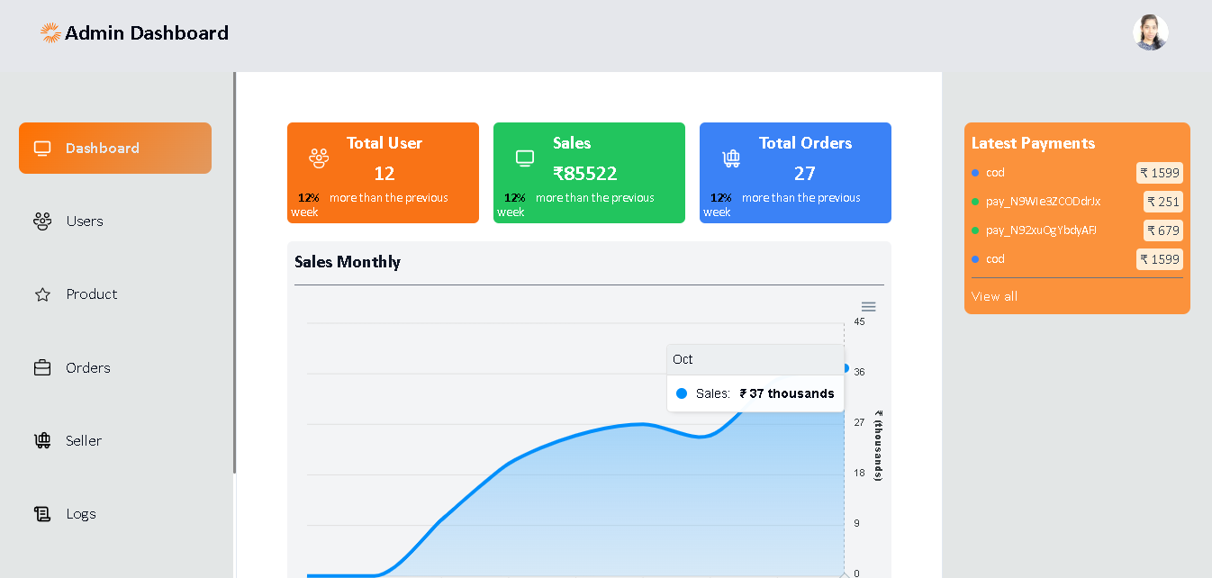

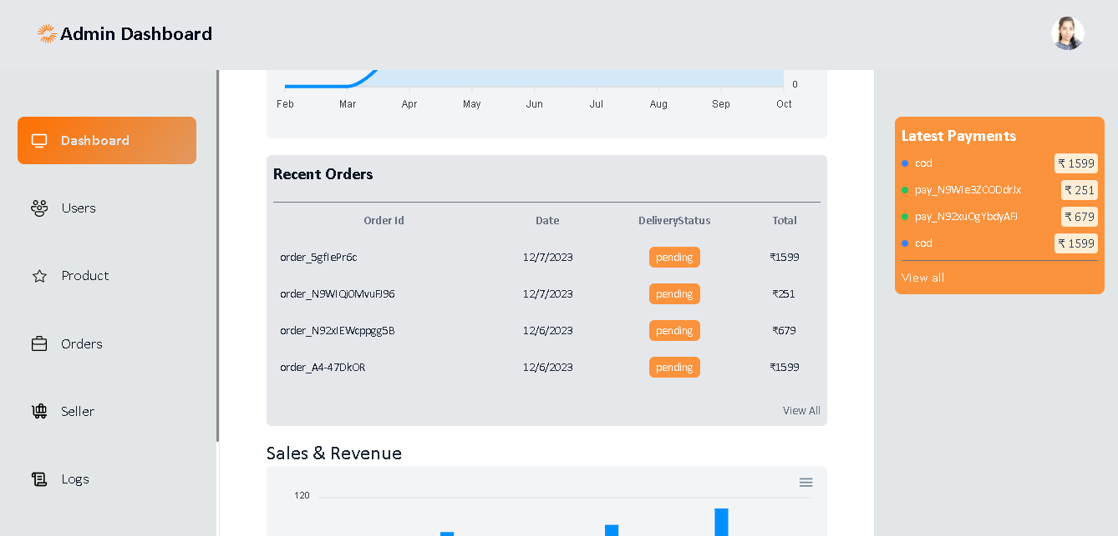

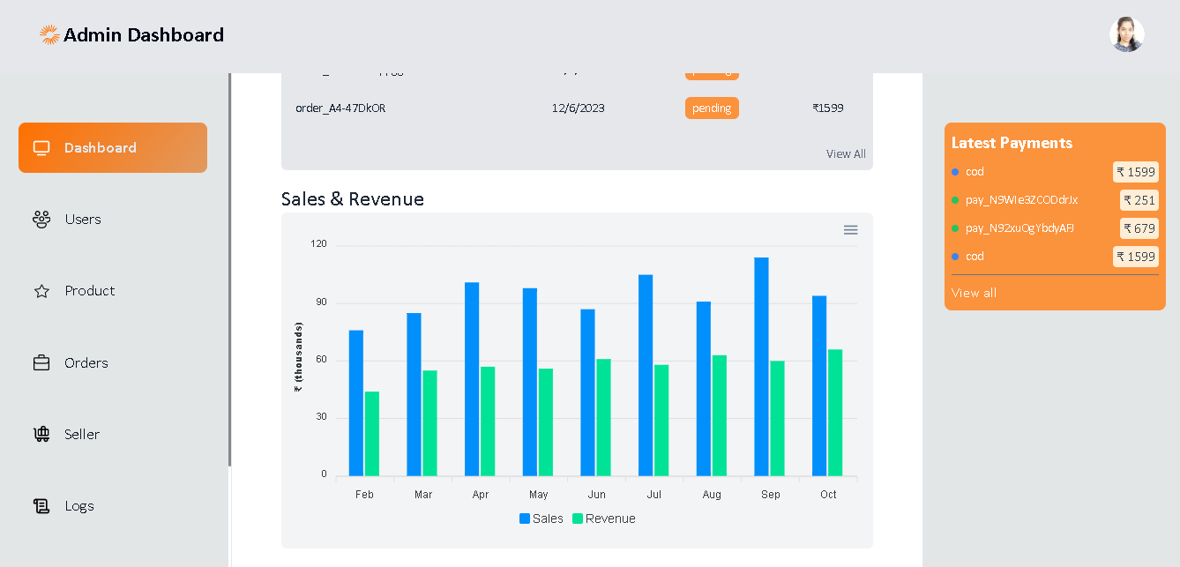

**2.USERS**

**This is a user’s page of our admin dashboard. Here admin can search and see the users of our ecommerce.**

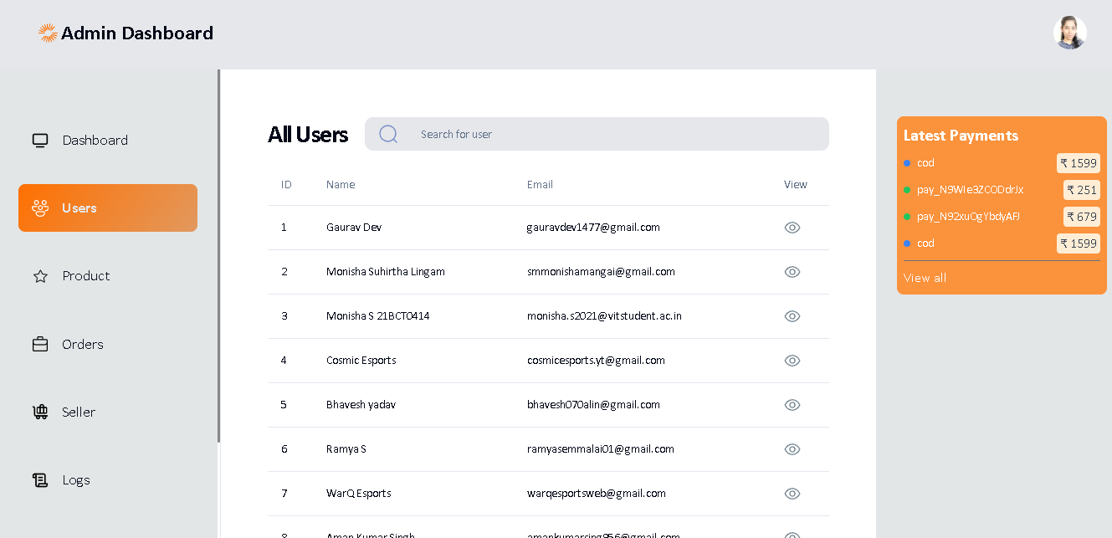

**It contains 4 columns. They are ID, NAME, EMAIL ADDRESS AND VIEW.**

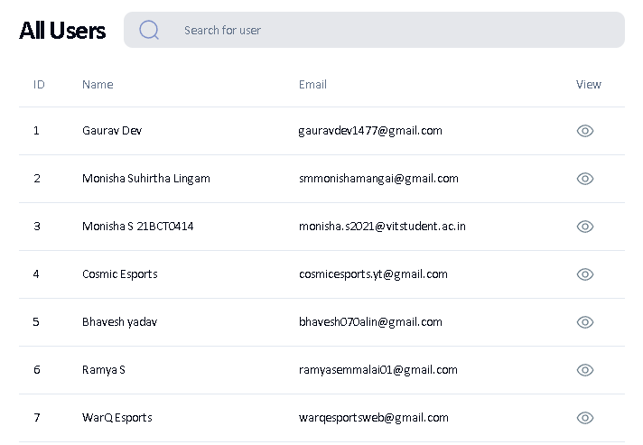

**ID 🡺 Represents the ID of the particular user**

**NAME 🡺Represebts the NAME of the particular user**

**EMAIL ADDRESS 🡺 Represents the Email Address of the particular user**

**VIEW 🡺Redirect to a page which contains NAME.EMAIL ADDRESS, PRIMARY NUMBER AND CLERK ID of the particular user**

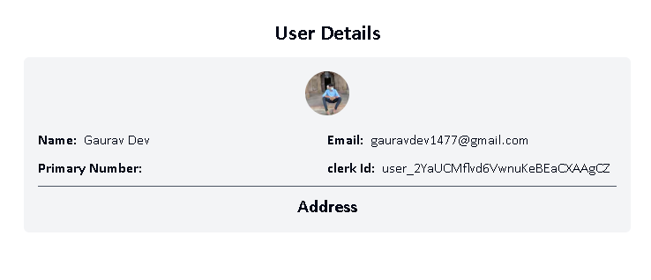**3.PRODUCTS:**

**This is a products page of our ecommerce which contains the all-available products details of our ecommerce. And also, admin can search and add the new products.**

**ADD NEW PRODUCT**

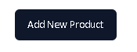

**By clicking this button, Admin can add the new products in order the fill the product details.**

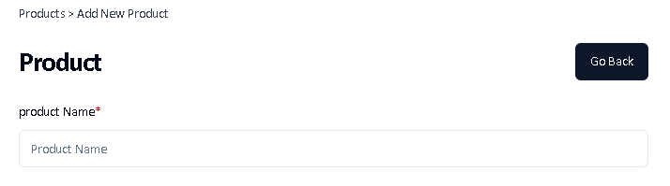

**Here name of the new products is needs to fill.**

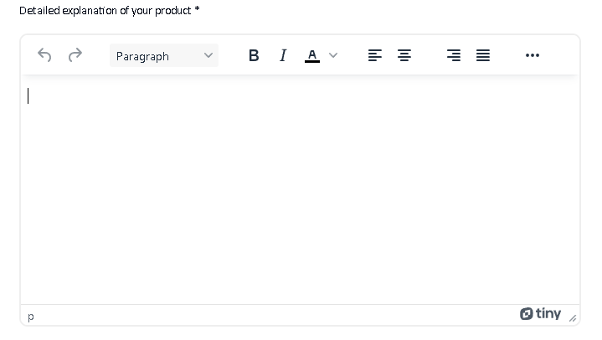

**Here detailed explanation of the new products needs to fill. And the paragraph should contains at least 20 character.**

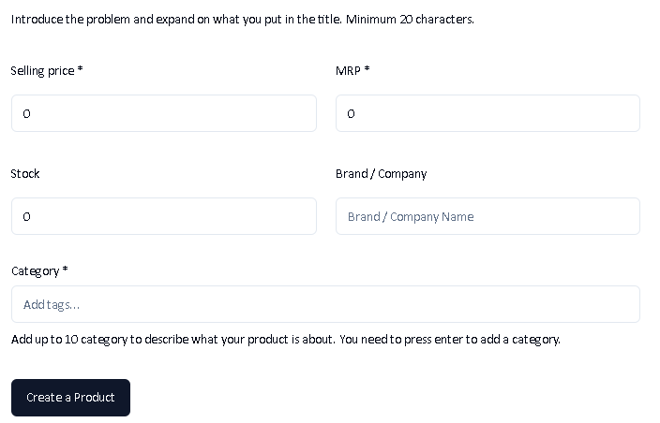

**Here admin needs to fill**

**Selling price of the new product**

**MRP of that new product**

**Number of stocks**

**Brand or company name of that new product**

**Available categories (We can add up to 10 categories)**

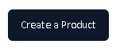

**CREATE PRODUCT 🡺 By Clicking this button admin can store the new product in the product list.**

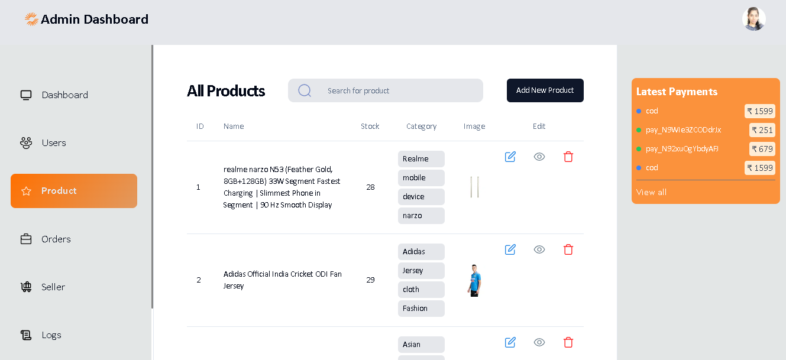

**Product page contains six columns. They are ID, NAME, STOCK, CATAGARY, IMAGE and EDIT.**

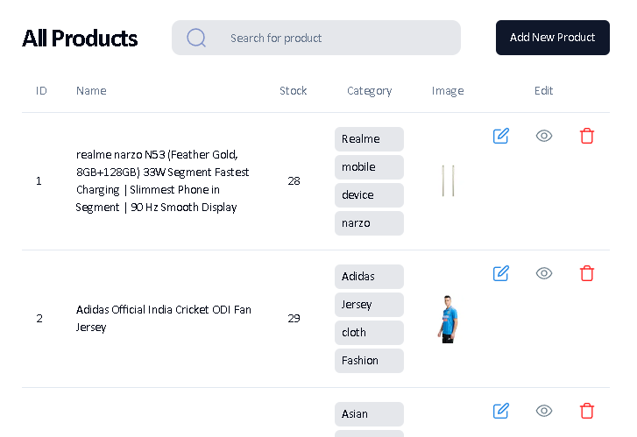

**ID 🡺Represents the Serial Number of the the table**

**NAME 🡺Represents the Name of the product**

**STOCKS 🡺Represents the available numbers of particular products**

**CATEGORY 🡺Represents the various category of that particular product**

**IMADE 🡺Represents the IM AGE of that particular product**

**EDIT 🡺In this admin can EDIT, VIEW and DELETE the product as per the requirement.**

 **By clicking this, admin can edit the product details.**

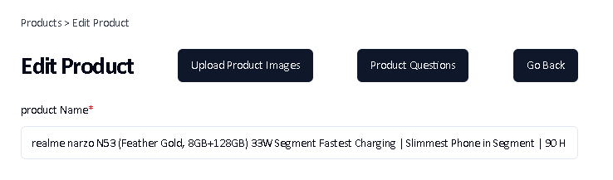

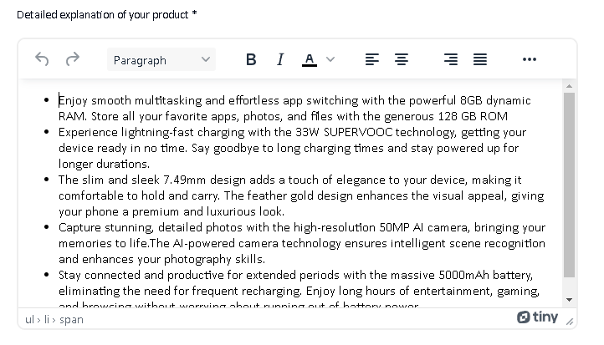

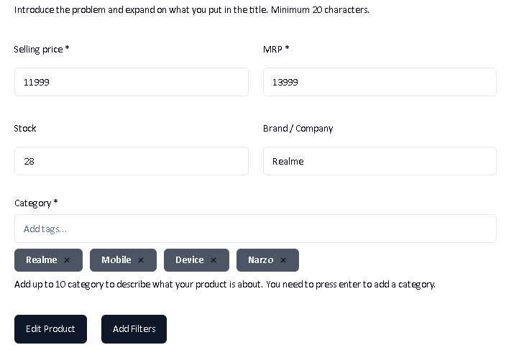

**By clicking this admin can only see that particular product details**

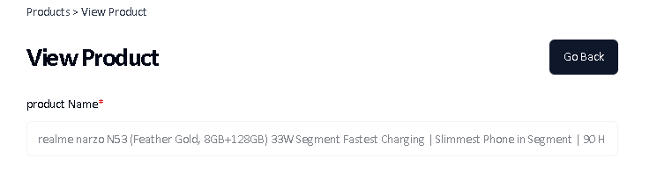

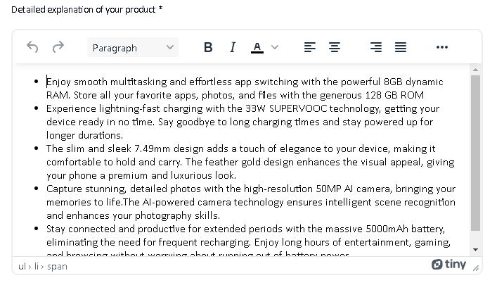



 **By clicking this, admin can delete the product from product list.**

**This is the pagination of this page. Admin can move pre or Next.**

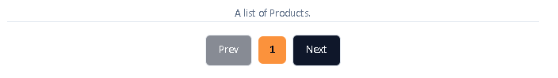

**ORDERS: This is the order page of our dashboard. It contains the order details represented by a table. And also, admin can search and select the filters to find the order.**

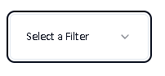

**This select filter contains some options which are**

* **Pending**
* **Dispatched**
* **Delivered and**
* **Cancelled**

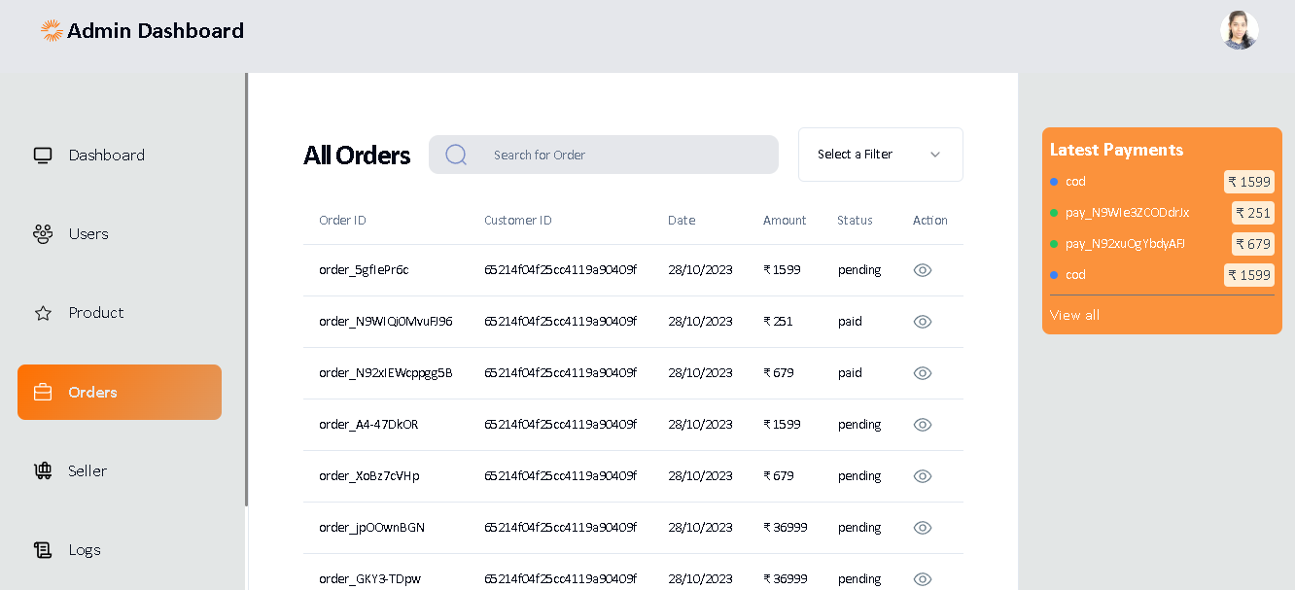

**All orders table contains totally 6 columns which are ORDER ID, CUSTOMER ID, DATE, AMOUNT, STATUS and ACTION**

**ODER ID 🡺Represents the ID of the particular order**

**CUSTOMER ID 🡺Represents the ID of the Customer**

**DATE 🡺Represents the date of order**

**AMOUNT 🡺Represents the amount of the order**

**STATUS 🡺Represents the SATUS of the order like Pending or Paid**

**ACTION 🡺Represents the ORDER DETAILS, delivery ADDRESS and PRODUCT DETAILS**

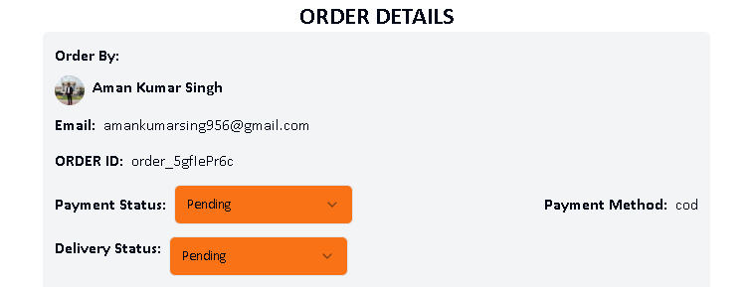

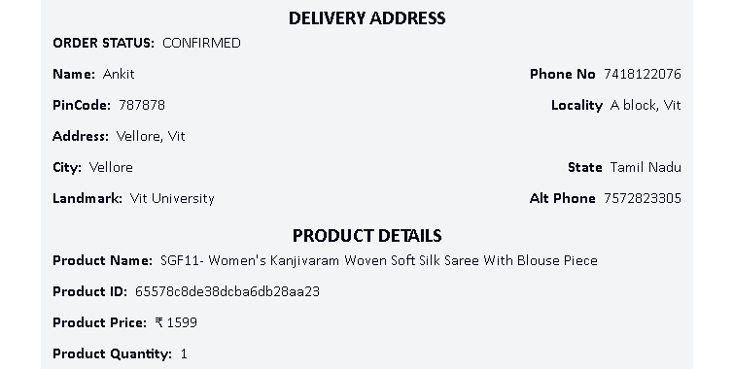

**4.SELLER: This is the SELLER PAGE; it contains the details of the SELLER of our ecommerce. And also admin can search and select filters to find the seller details.**

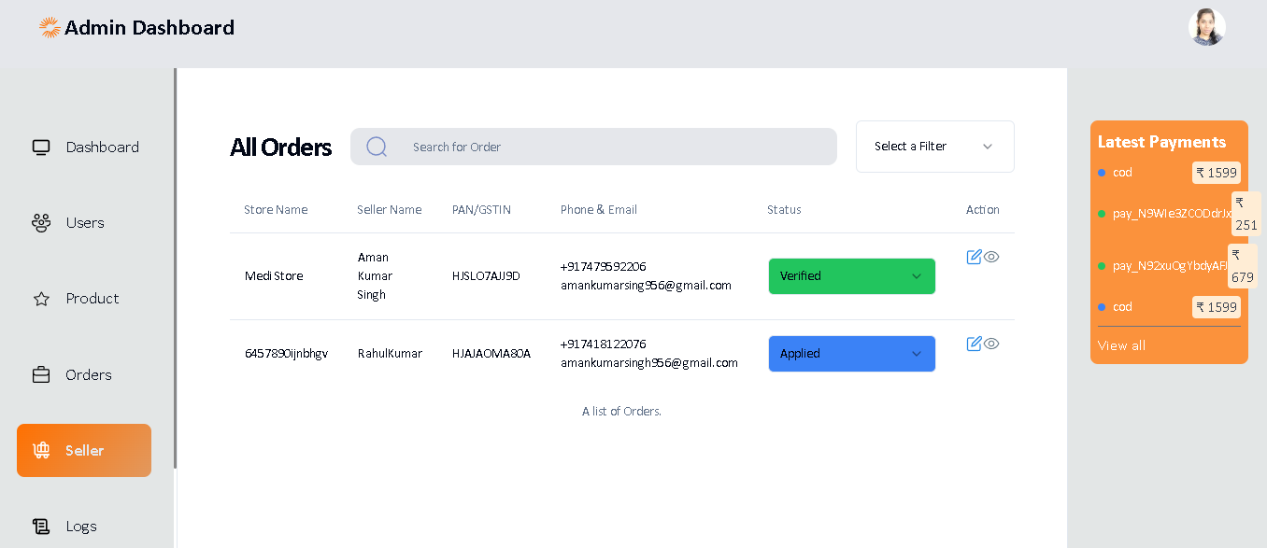

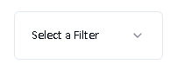

**Select Filter contains**

* **Pending**
* **Applied**
* **Verified and**
* **Rejected**

**Which applied in status column**

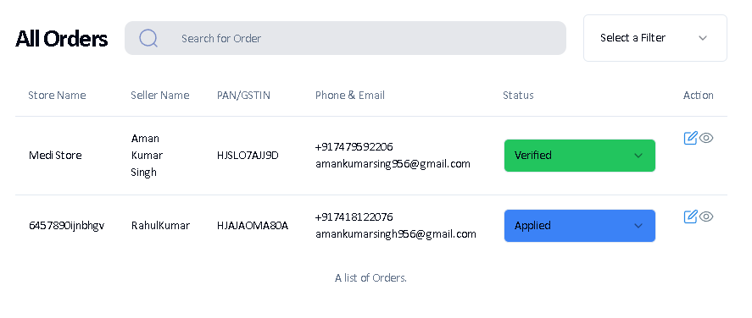

**All orders page contains totally six columns which are STORE NAME, SELLER NAME, PAN/GSTN, PHONE&EMAIL, STATUS AND ACTION**

**STORE NAME 🡺Represents Seller store name**

**SELLER NAME 🡺Represents Name of the seller**

**PAN/GSTN 🡺Represents the Pan/GSTN code**

**PHONE&EMAIL 🡺Represents the phone number and Email Address of the Seller**

**STATUS 🡺Represents the status of the seller that is pending or applied or verified or rejected**

**ACTION 🡺Represents edit and view option**



**5.LOGS:**

**This is the logs page of our ecommerce which contains the SELLER LOG, CLIENT LOG AND ADMIN LOG. It’s displayed the overall logs as per the order. If the admin wants to go with the specified logs, then admin can go by the clicking the above specified button. And admin can search the logs by using any of the detail of the logs.**

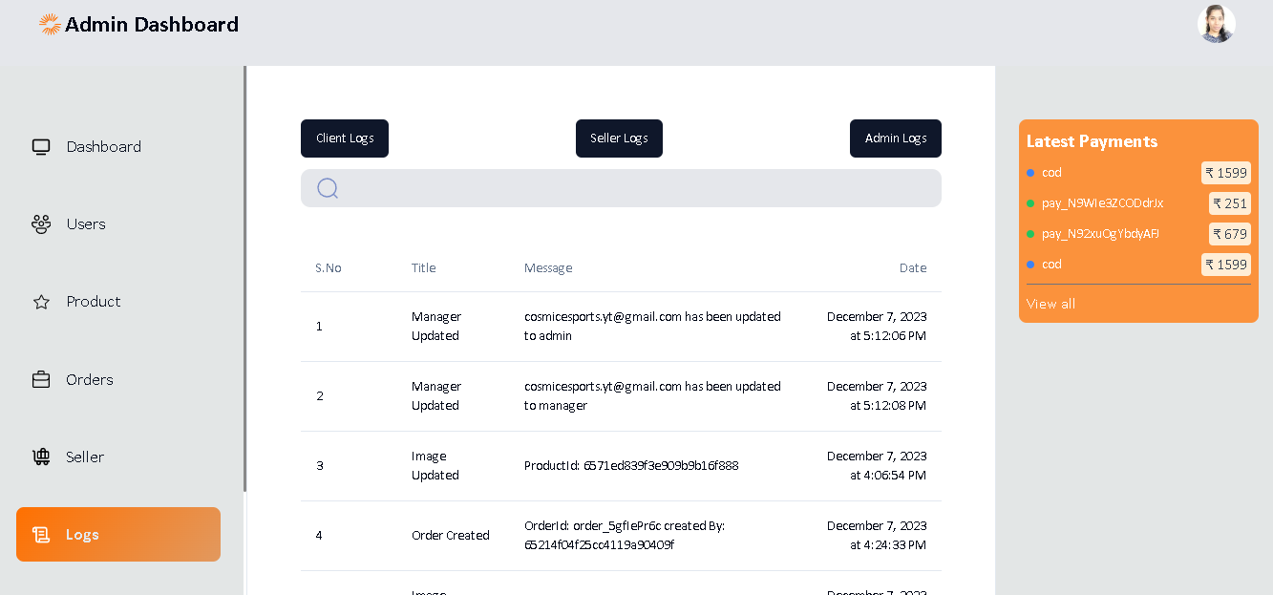

**CLIENT LOG**

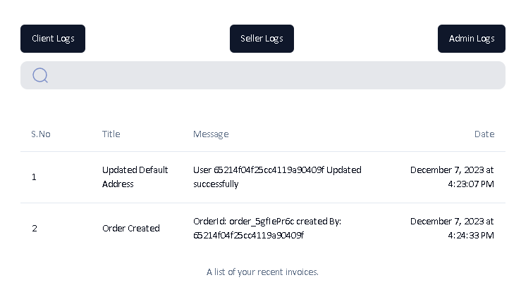

**SELLER LOG**

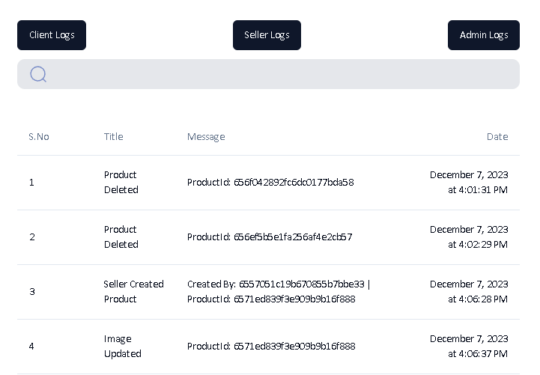

**ADMIN LOG**

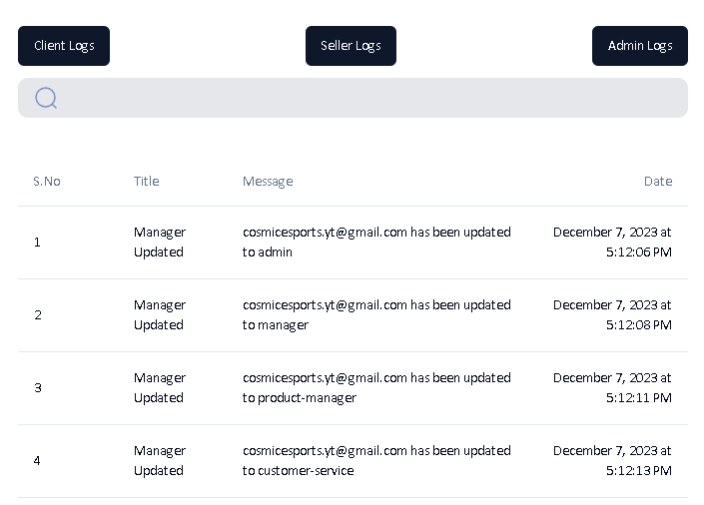

**DESIGN AND IMPLEMENTATION OF E-COMMERCE ADMINBSITE ONLINE SHOPPING**

**ADMINB PAGE DETAILS:**

**HOME PAGE** : THIS IS THE HOME PAGE BEFORE SIGN IN

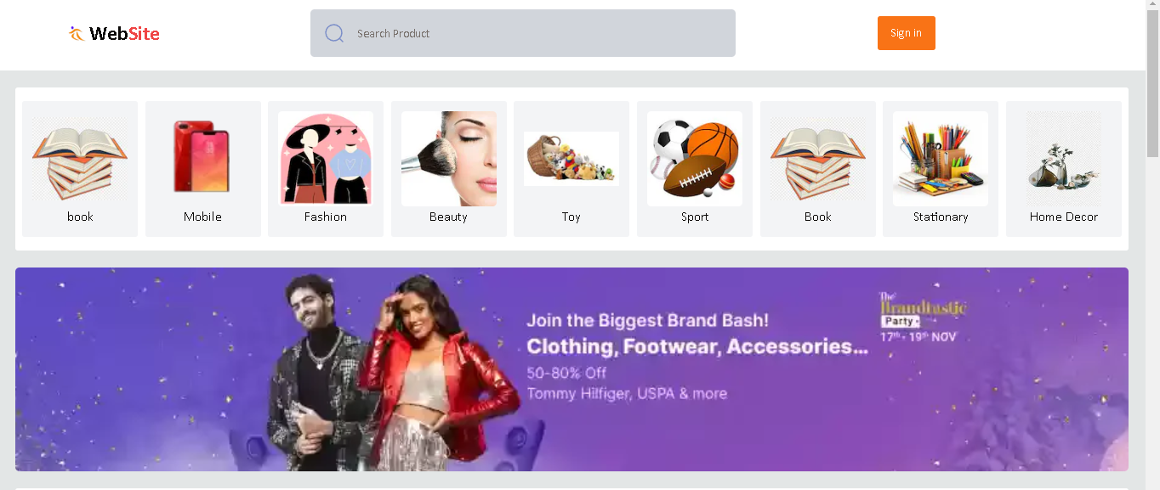

**SIGN UP PAGE FOR CUSTOMER:**

**New users can register here. Customers** will have the right to log in with their information such as first name, last name, mobile no, e-mail and password . The information is sent to the database to check for a match. If no match is found the customer remains on the same page with error message, otherwise admin will sent the verification code on your mail id. After verification, admin will directed to the customer page.

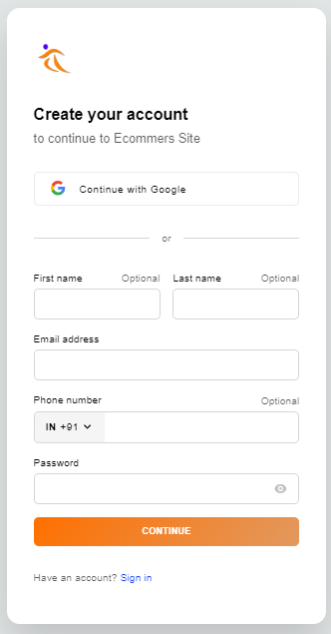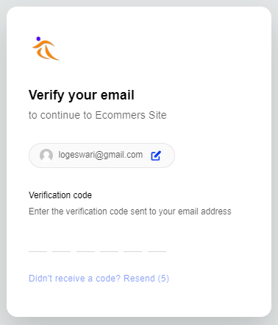

**NO ACCOUNT: If you don’t have an account then follow these steps**

Sign In

**Or**

Continue with Google

Fill the below details

Choose an Account

First Name

Last Name

Email Address

Phone Number

Password

**continue**

Verify Your Email (Fill OTP which was sent to your Email Address)

**Your created an account**

Home page

**SIGN IN PAGE FOR CUSTOMER: Login page for both users and administrators**.

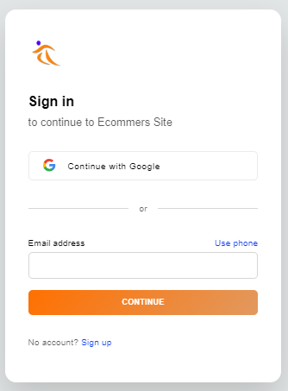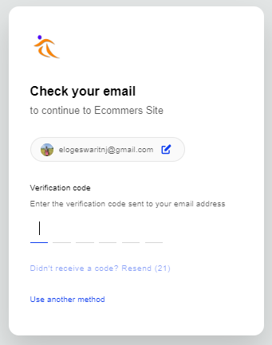

SIGN IN

Email Address

Continue with Google

**Continue**

Enter OTP (Which send to your email id)

Choose an Account

Home Page

**HOME PAGE :THIS IS THE HOME PAGE AFTER SIGN IN**

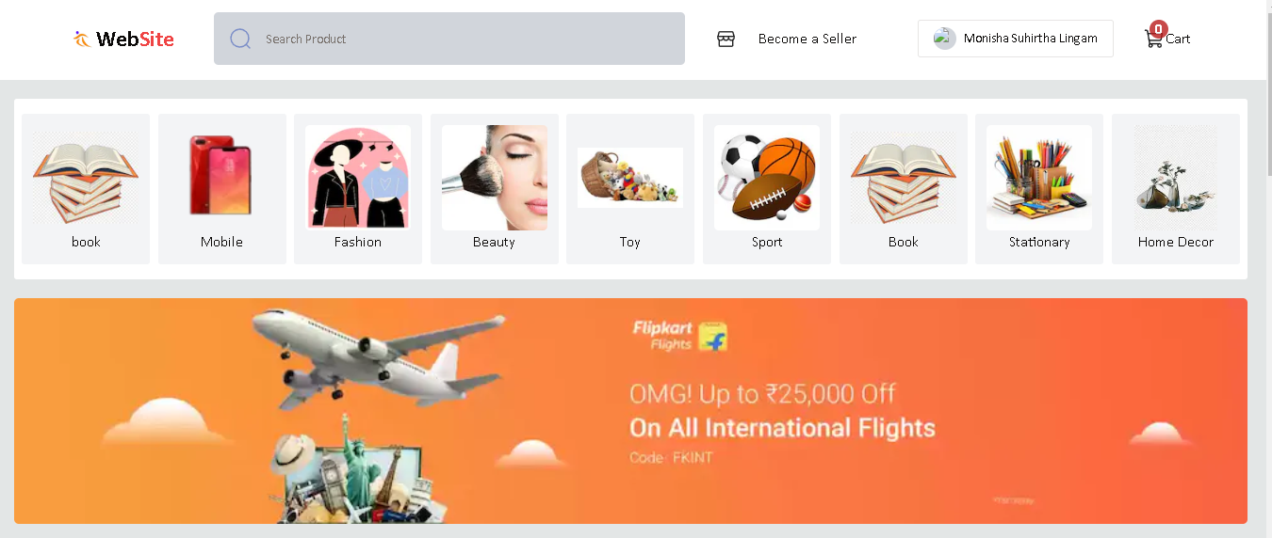

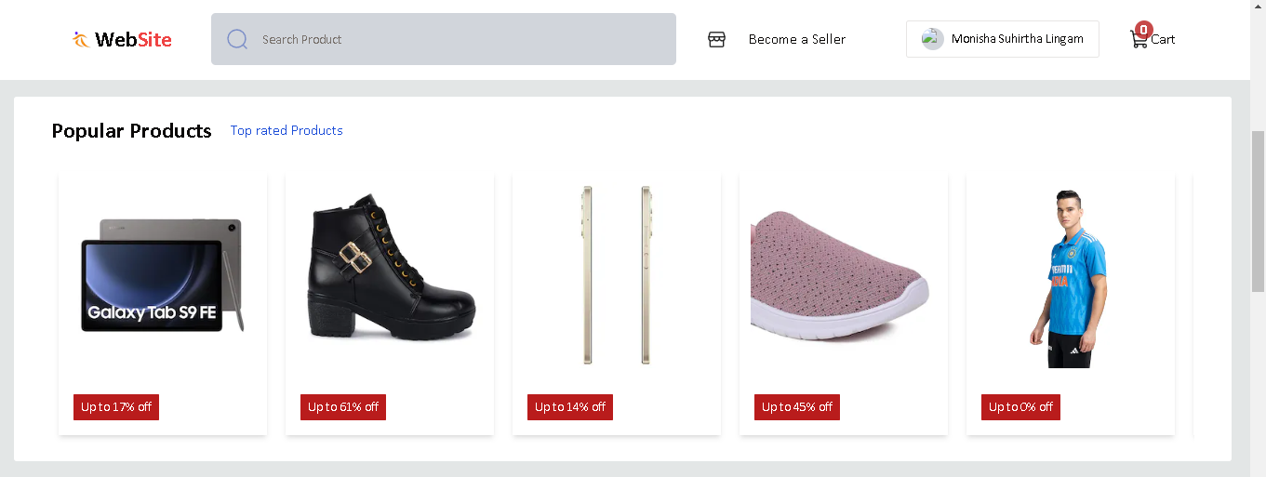

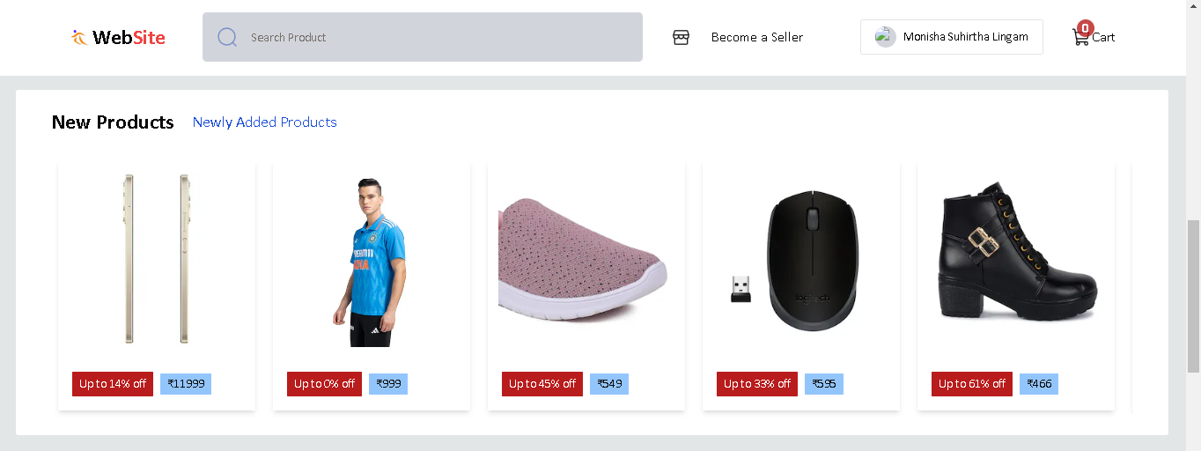

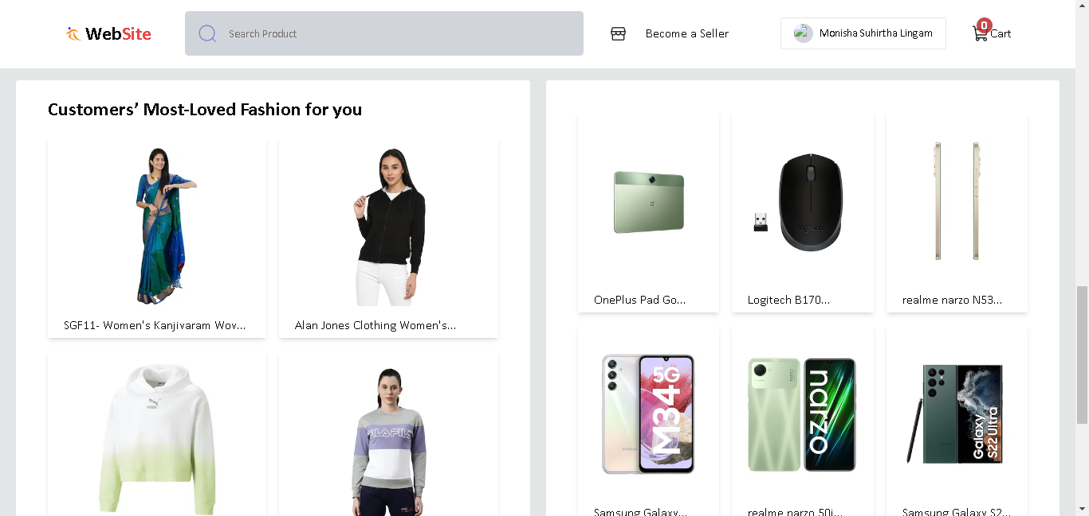

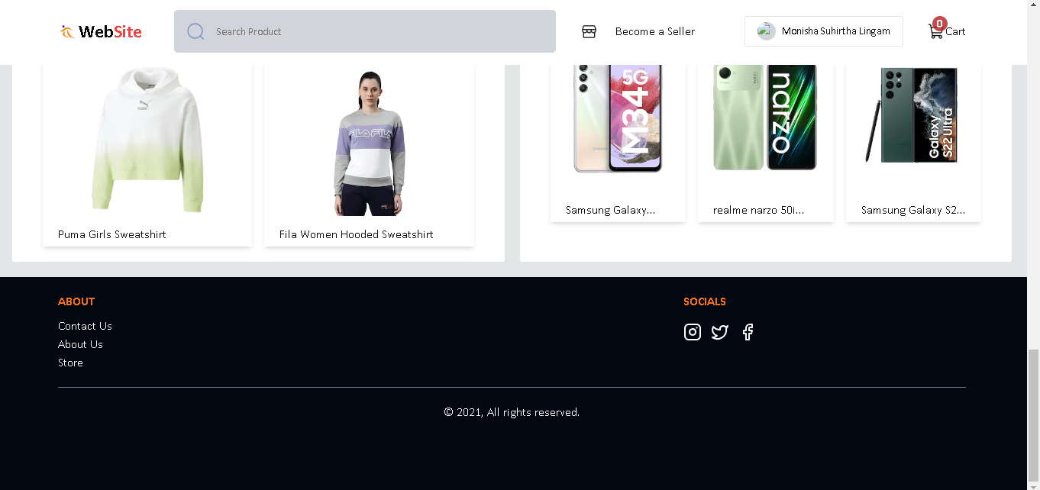

**MENU BAR: This is a Menu Bar of our ecommerce**



**SEARCH BAR: This is a Search Bar of our ecommerce**

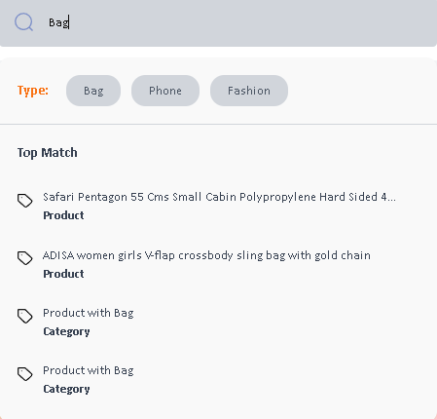

**ACCOUNT PAGE:**

**This is a My Account Button. Under this admin have MY Profile,Store,Orders,Wishlist,Notifications,Customer Care and Logout URLs**

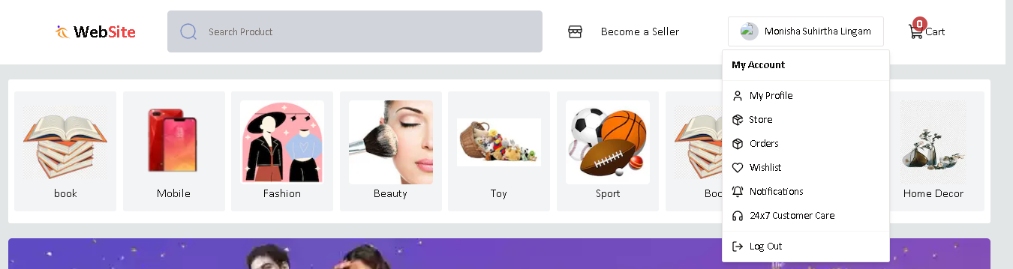

**SLIDING WINDOW :**

**This is a image sider section of the ecommerce**



**POPULAR PRODUCTS:**

**This contains only popular products. Where customer can add to cart a product, can view products information, can view Products Questions and ansadminrs and Reviews.**

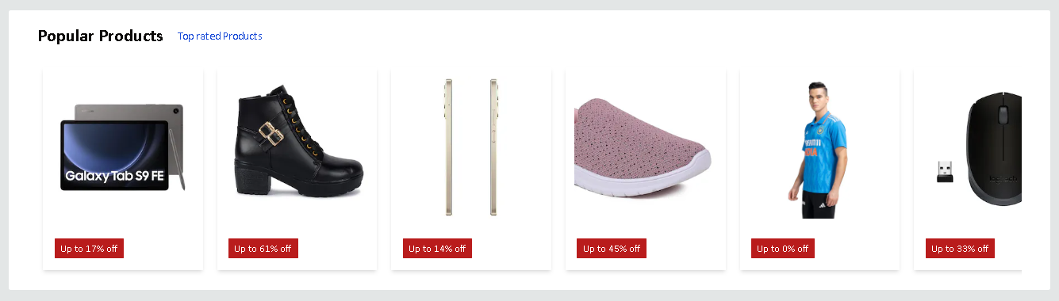

**NEW PRODUCTS:**

**This contains only newly arrived products. Here also, customer can add to cart a product, can view products information, can view Products Questions and ansadminrs and Reviews.**

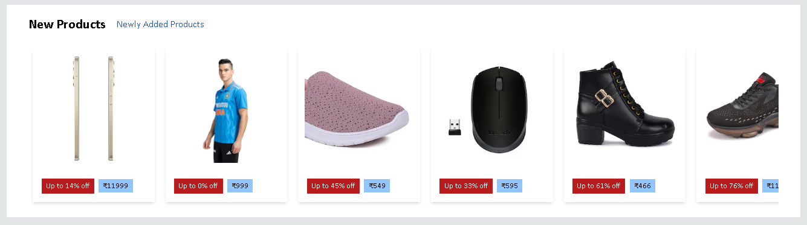

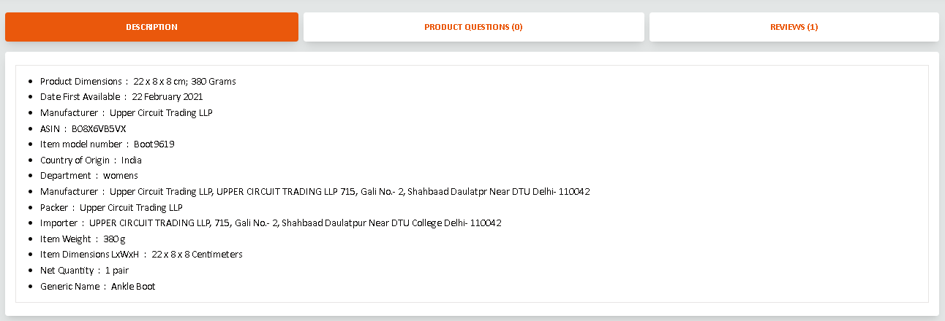

**MOST LOVED(SUGGESTION):**

**This contains only most loved products by customers based on reviews. Here also, customer can add to cart a product, can view products information, can view Products Questions and ansadminrs and Reviews.**

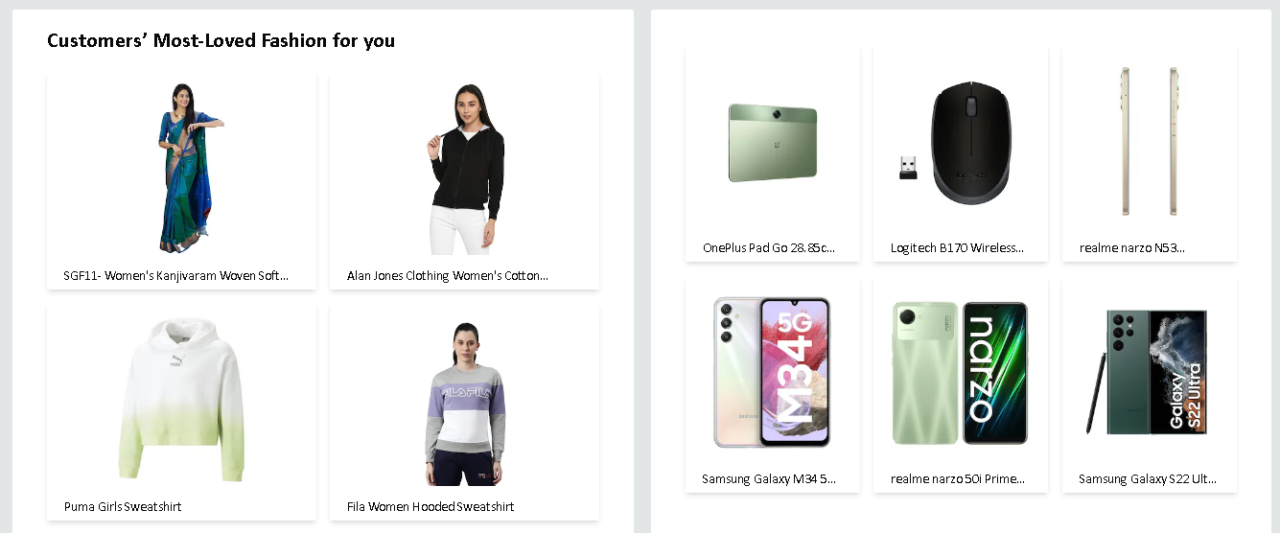

**PRODUCT DESCRIPTION PAGE:**

**This page show product description. Where customer can add to cart a product, can view products information that sort by product name, filter by product price, can search a product according it’s keyword and can show pages according product quantity. In the sidebar of this page also have categories, reviews, product questions.**

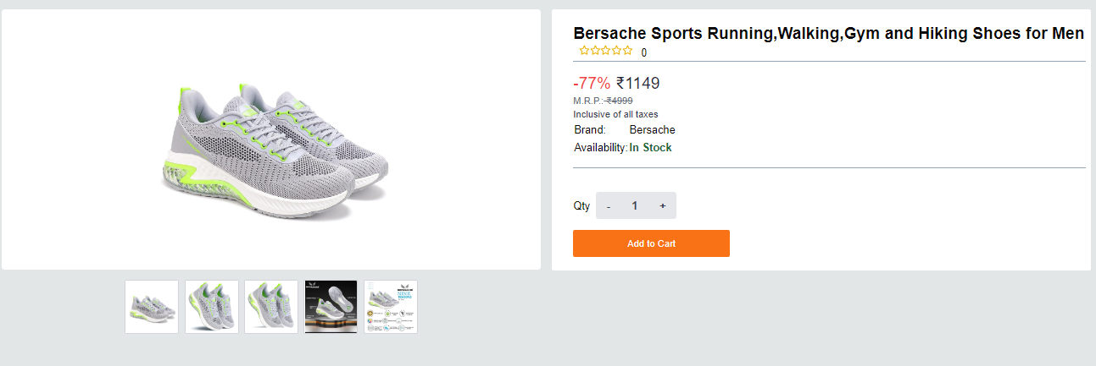

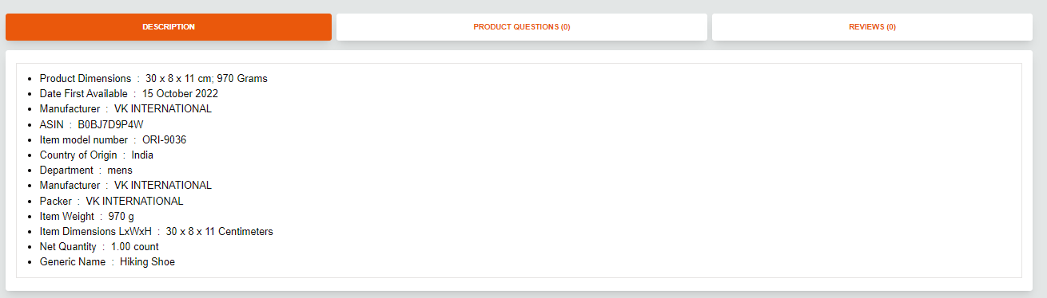

**REVIEW:**

**This is review page our ecommerce. It is shown below the all-unique items. Here buyers can leave the comments of the particular products and also, they can see others review before buying that product. And also, this contains an EDIT option for modify the reviews.**

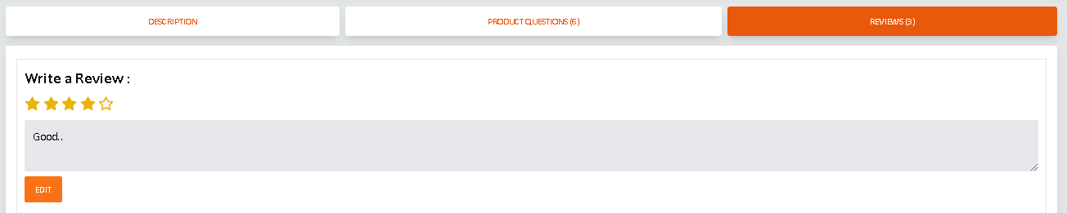

**PAGINATION:**

**This is a pagination menu. By this menu admin can move next and previous pages.**

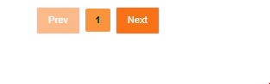

**ABOUT : This is about the ecommerce**

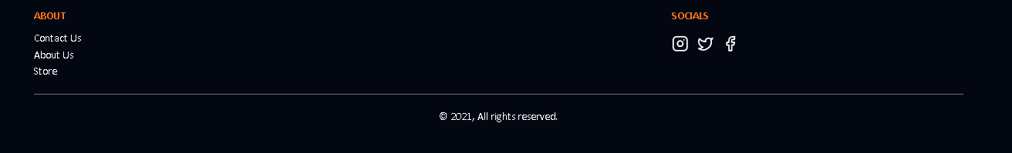

**MY ACCOUNT :**

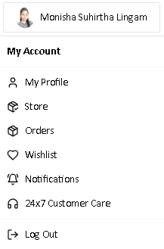

**MY PROFILE :**

**This contains customers personal information’s like Name,Photo,Email Id,Phone Number under Account option.And under the Security Option it contains password,Active Devices and Delete option of account if recuired.**

**Under Account:**

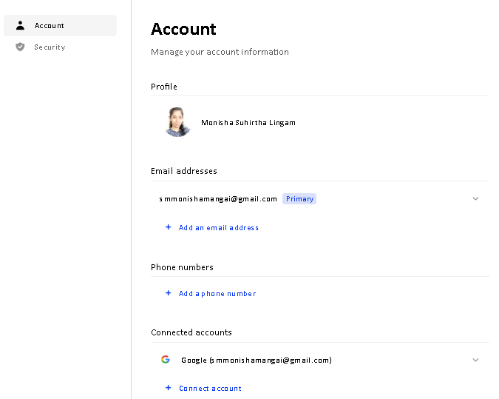

**Under Security:**

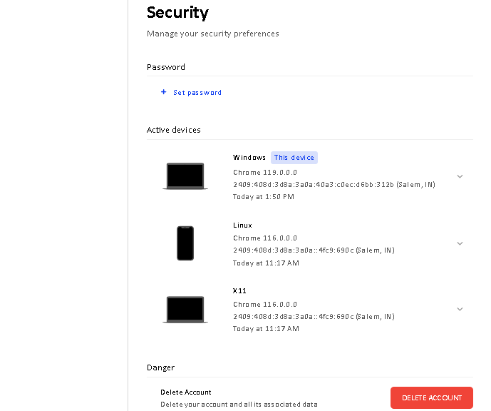

**STORE:**

**This store contains all categories of products. Admin can search the products with the help of category section like brands, price, gender, sort by.**

**Admin can choose the products brand wise.For example, admin have to buy a “Samsung galaxy s22 ultra 5G”.In this situation admin can select the “Samsung” in brand options.**

**Also admin can choose the products gender wise.For example, makeup, skincare, haircare essentials and dresses. These items are gender wise choosen.**

**Price section contains “min to max” option. Admin can select the price range for products with help of “min to max” option.**

**Also admin can search the products with the help of sort by section. This section contains “popularity”, “Price-high to low”, “price-low to high”, “Neadminst First” options.**

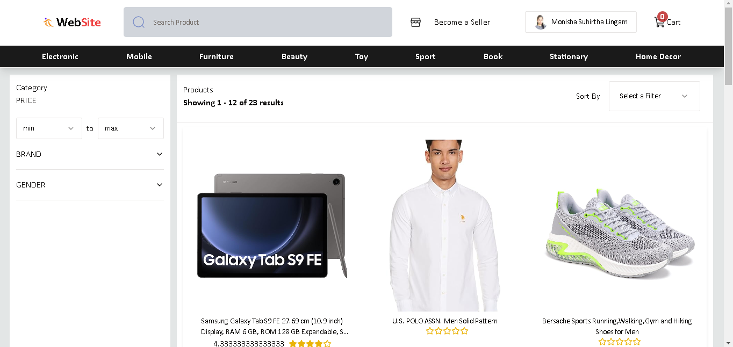

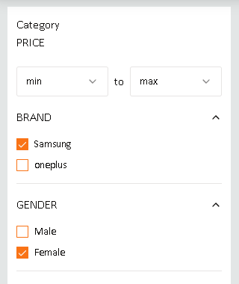 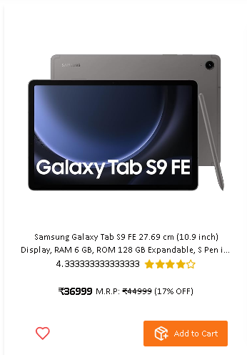

**WISHLIST:**

**This page contains only wishlist product, Where customer can view a product information that they have wished.**

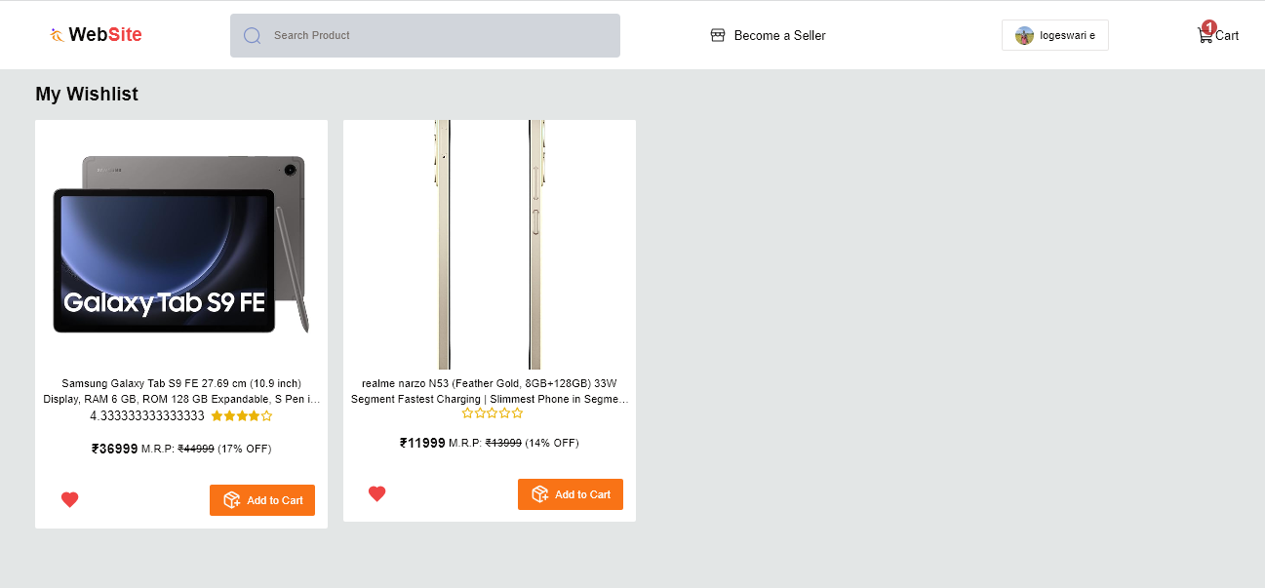

**MY CART:**

The customer can add products to the shopping cart. They can also update the shopping cart from time to time until they are done shopping. After that, they can check out by clicking on the checkout button.

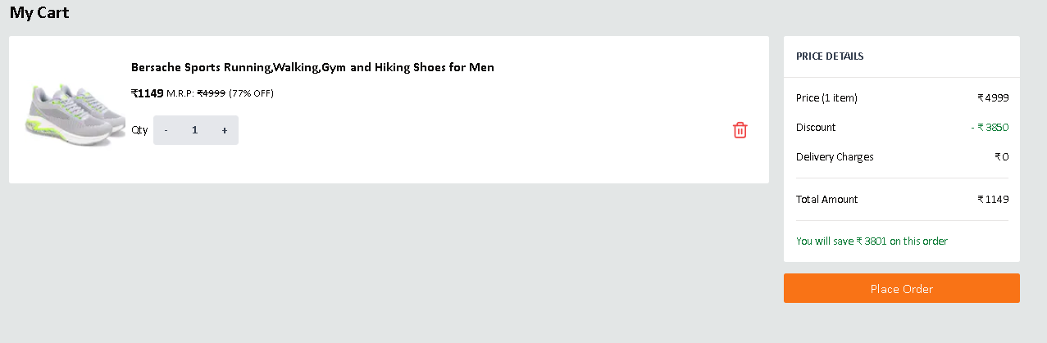

**CHECK OUT PAGE:**

**This contains only the number of items. Which can be ordered by the clicking “place your order” button. And here admin need to give address by clicking “New Address” and admin can select the mode of payment.**

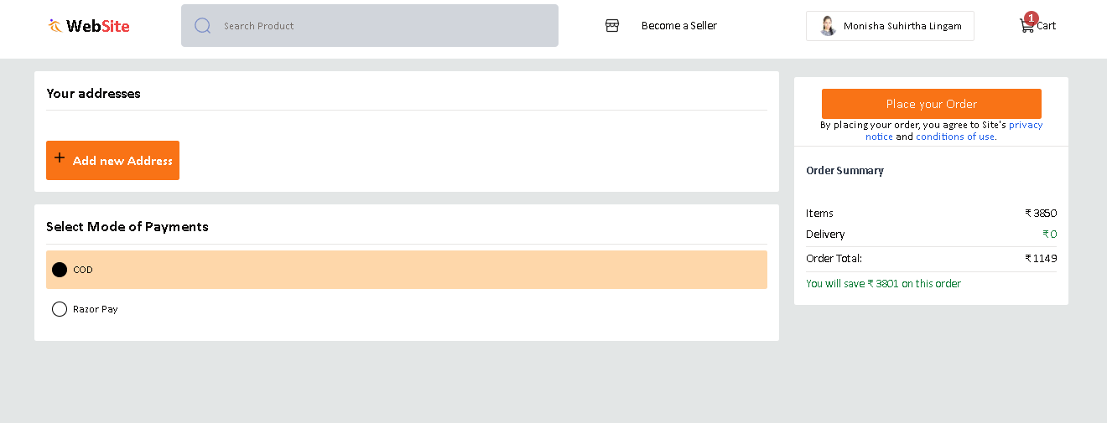

**PAYMENT OPTION PAGE:**

**Payment option sets payment type for product buying. It is the part of checkout page.The available payment types are card, UPI/QR, Net Banking, Wallet and so on. You can choose any one of these to continue the payment process.**

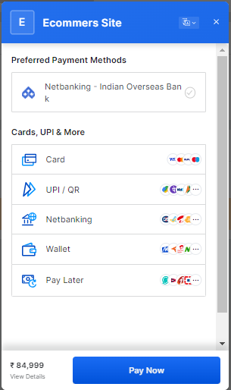

FOR EXAMPLE, Admin can select the Net Banking and choose the bank name and click the “Pay Now” button. Once the payment was done, you order is confirmed.

